Practical No. 11

Aim: Implement set operations, case statement and view queries.

Theory:
You can perform various operations to retrieve, manipulate, and present data effectively by using, the Set operations allow you to combine and manipulate data from multiple tables or result sets. Common set operations include UNION, INTERSECT, and EXCEPT (or MINUS in some database systems). The CASE statement is a powerful conditional expression in SQL that allows you to perform conditional operations within a query. A view in a relational database is a virtual table that is generated by a query and represents the result set of that query.

Queries:
1)Implement “IF” Condition in Query
a) Put if condition on “price” attribute (IF Else)
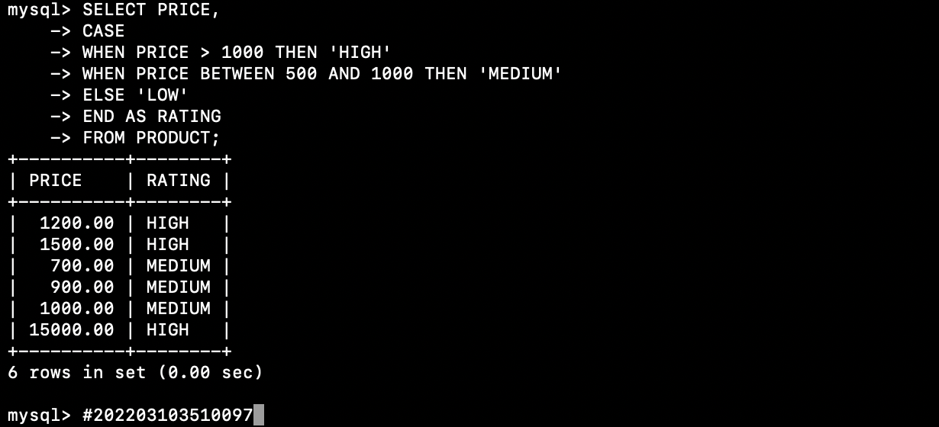
b) Try nested IF on “price” attribute.


c) Display Price and quantity and there rating with “High” , “Medium” and “Low”
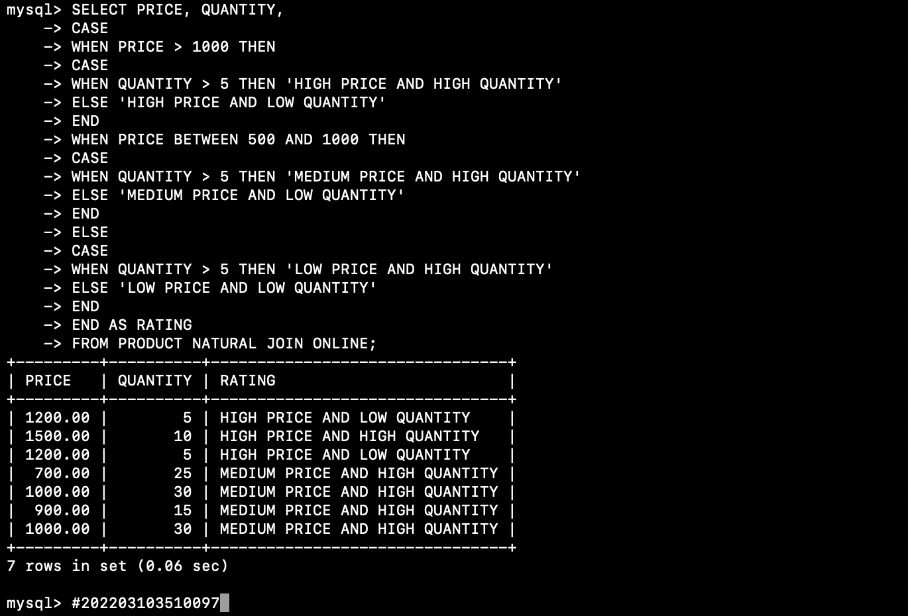

2) Create a view VProduct of product‟s id, description and price.

3) Create a view of Vorder to get orders (order_id, product_id, description, customer_name, quantity) placed by customer who belongs to “BRIXTON”.
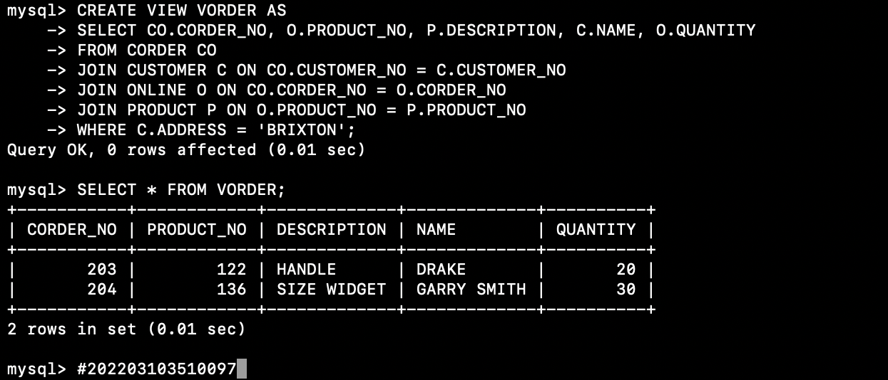

4) Insert a new row in VProduct 135, „Sofa‟ and 35000.
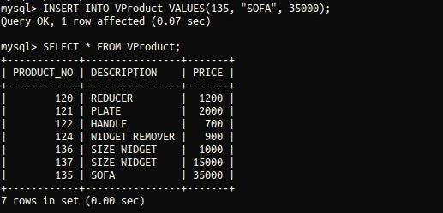

5) Update product‟s quantity to 25 which is brought by customer „DRAKE‟ in Vorder.
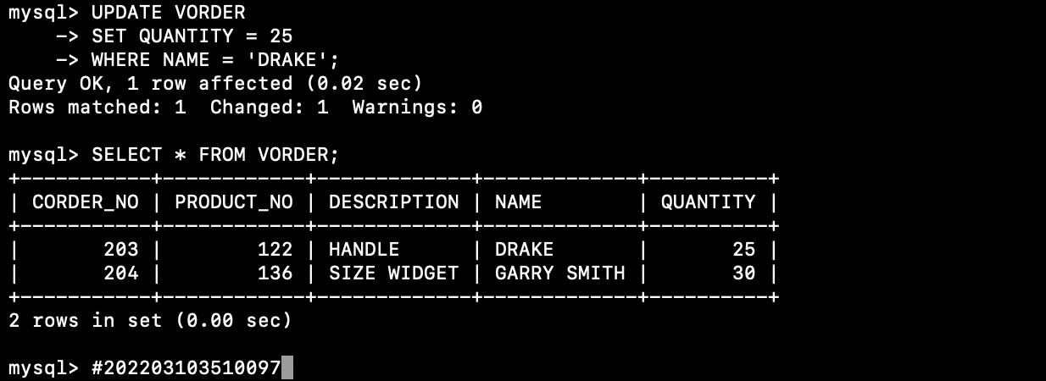

6) Delete details of product id 121 from VProduct.
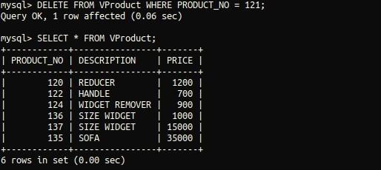

7) Delete view VProduct.


8) Display name of all customers and all suppliers with their id by using union operator.
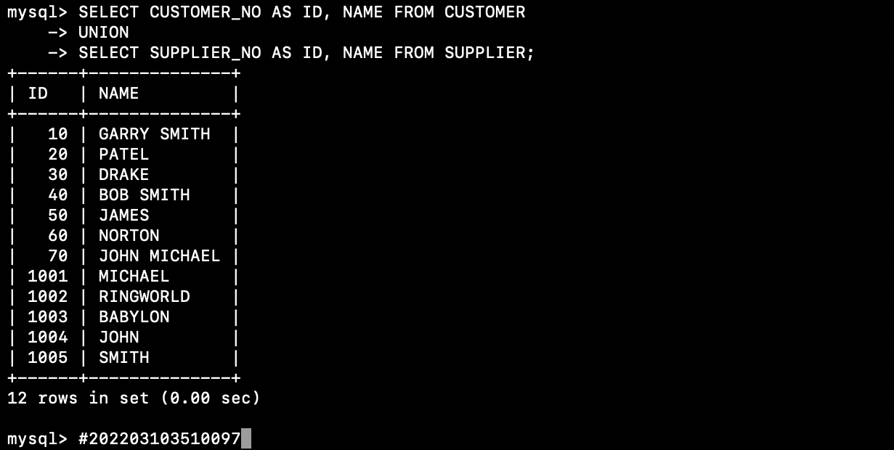

9) List product which are not bought by any customer using minus operator.
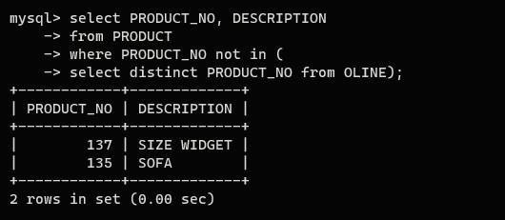

10) Give the name of suppliers who is also customer.


Conclusion: Set operations, CASE statements, and views are essential SQL features that allow you to combine, transform, and present data effectively. By mastering these SQL techniques, you can work with data in a more flexible and efficient manner, providing valuable insights and functionality in database management and application development.

